ULEZ scrappage schemes evaluation report
November 2022
Contents
Executive summary 4
1. Introduction and background to the schemes 7
1.1 Van and minibus scrappage scheme 8
1.2 Heavy vehicle scrappage scheme 9
1.3 ULEZ car and motorcycle scrappage scheme (UCMSS) 10
1.4 Other scrappage financial support schemes in the UK 11
2. Scrappage scheme operations 13
2.1 Scrappage application process 13
2.2 Impact of scrappage schemes 14
2.2.1 Van and minibus scrappage scheme 15
2.2.2 Heavy vehicle scrappage scheme 17
2.2.3 Car and motorcycle scrappage scheme 19
2.2.4 Scrappage emission benefits 24
2.2.5 Third-party offers 25
3. Car and motorcycle scrappage scheme survey 26
3.1 Perceptions of the scheme 27
3.2 Third-party offers 28
3.3 How the grant money was used 28
3.4 Behaviour change 30
3.5 Implications for potential future scrappage schemes 31
3.6 Key survey findings 32
4. Recommendations for potential future schemes 33
Appendices 34
Appendix 1: Eligible benefits for UCMSS grant payments with example scenarios 34
Appendix 2: Car and motorcycle scrappage uptake by borough 40
Appendix 3: Other scrappage financial support schemes comparisons 41
UK comparisons 41
International comparisons 44
Appendix 4: Scrappage financial support schemes sources 45

List of Figures

Figure 1: Van and minibus scrappage applications rate 9
Figure 2: Van and minibus scrappage applications at stage 1 of the process 16
Figure 3: Van and minibus scrappage scheme breakdown 16
Figure 4: Heavy vehicle scrappage applications processed breakdown 17
Figure 5: Breakdown of heavy vehicles scrapped and replaced 18
Figure 6: Breakdown of heavy vehicles retrofitted 18
Figure 7: Car and motorcycle applications processed breakdown 20
Figure 8: Recipients of UCMSS grant payment by area in London 21
Figure 9: Index of multiple deprivation 2019, LSOAs in London 22
Figure 10: Borough breakdown of recipients of the UCMSS grant, including areas of high and low deprivation 23
Figure 11: Use of scrappage grant payments 29
Figure 12: Percentage change in mode use by recipients of the UCMSS grant payments 30
Figure 13: Net change in mode use by recipients of the UCMSS grant payments 31
Figure 14: Interest in alternative grant payment options 31
Figure 15: Car and motorcycle scrappage uptake by borough 40

List of Tables

Table 1: Other scrappage financial support schemes in the UK 11
Table 2: High-level breakdown of scrappage scheme eligibility 13
Table 3: Final scrappage figures across all scrappage schemes 15
Table 4: estimated emissions savings from the three scrappage schemes with and without vehicle replacement 25
Table 5: Third-party offers available to successful UCMSS and van and minibus scrappage scheme applicants 26
Table 6: Perceptions of the ease of the application process 27
Table 7: Eligible benefits for UCMSS grant payments with example scenarios 34
Table 8: Class of CAZs in the UK outside London 41
Table 9: Status of UK CAZs 42

Executive summary
The Mayor of London’s scrappage schemes were successful in helping Londoners prepare for the expansion of the Ultra Low Emission Zone (ULEZ). The £61 million provided by the Mayor supported many Londoners on lower incomes, disabled Londoners, small businesses and charities who would have found it more difficult to afford to adapt to the ULEZ, its expansion and the tightening of the Low Emission Zone (LEZ) standards.
The £61 million scheme has been the biggest of its kind in the UK to date, despite the UK government not offering the same financial support for scrappage as they have offered to six other cities to date, with more planned. These cities include Birmingham (£38 million), Bristol (£42 million) and Bradford (£30 million) to support their Clean Air Zones (CAZs), which have been recently launched in the UK.
As well as helping them avoid paying a ULEZ charge, we have found that many of those who used the scrappage schemes have reduced their vehicle ownership and changed their travel habits towards more sustainable modes of transport.
From February 2019, the Mayor introduced a series of vehicle scrappage schemes, starting with a scheme for vans and minibuses, followed by a car and motorcycle scrappage scheme for Londoners on lower incomes and disabled Londoners, which opened in October 2019. Finally, a scheme for heavy vehicles opened in September 2020. These schemes were very popular, with all funding being allocated by 24 November 2021, shortly after the expansion of the ULEZ on 25 October 2021.
The scrappage schemes removed 15,232 older and more polluting vehicles from London’s roads. The breakdown across vehicle types is shown below: 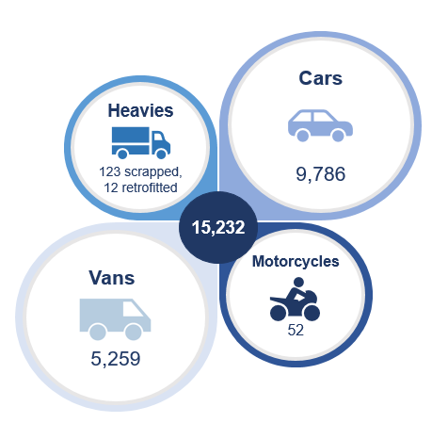
Scrappage schemes can also be used as an effective policy intervention in removing NOx, PM2.5 and CO₂ from London’s roads. It is estimated that the scrappage schemes have supported the removal of a total 140 tonnes of NOx, 0.5 tonnes of PM2.5 and 2,000 tonnes of CO₂.
Following the closure of the ULEZ Car and Motorcycle Scrappage Scheme (UCMSS), we issued an online questionnaire using research agency 2CV to better understand the impacts of the scheme. The results show that the scheme was effective in reducing vehicle ownership and changing travel behaviour, supporting the Mayor’s target of 80 per cent of all trips in London to be made on foot, by cycle or using public transport by 2041.
Key results show:
- A third of recipients did not purchase a replacement car or motorcycle
- UCMSS has supported the estimated removal of 50 tonnes of NOx,
0.2 tonnes of PM2.5 and 500 tonnes of CO₂ (using new vehicle
replacement data from the survey)
- 22 per cent no longer have access to a vehicle in their household
- Net increases were seen in walking (22 per cent), cycling (5 per cent), bus use
(16 per cent), Underground travel (4 per cent) and rail travel (1 per cent)
- There was an overall decrease in recipients’ car travel (minus 2 per cent)

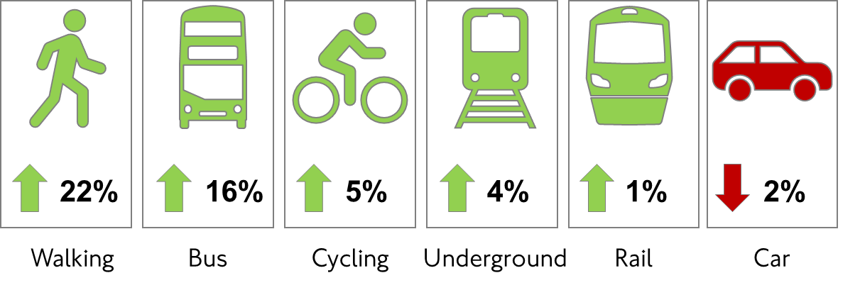
For any future scrappage scheme, it is key that the successes of the previous scrappage schemes are built on to maximise impact, including:
- A clear and simple-to-use application process
- A comprehensive multichannel marketing campaign and stakeholder engagement, to reach eligible audiences effectively and ensure awareness of third-party offers
- Increased alternatives to the grant payment to maximise mode shift, in line with
the Mayor’s Transport Strategy, including a wide range of third-party offers

1. Introduction and background to the schemes
The Mayor’s Transport Strategy was adopted in March 2018, setting out a bold approach to making streets work for people through the Healthy Streets approach. Improving London’s air quality is a key pillar of this strategy, with emissions from transport blighting residential streets, harming human health and contributing to climate change. The Mayor’s Transport Strategy contained a proposal to introduce an emissions-based charge to address this.
The Ultra Low Emission Zone (ULEZ) was introduced on 8 April 2019 in the same area as the Congestion Charge zone and then expanded up to but not including the North and South Circular roads on 25 October 2021. In March 2021, the Low Emission Zone (LEZ) standards for heavy vehicles across most of Greater London were also tightened to match the ULEZ standards.
The ULEZ standards are:
- Euro 3 for motorcycles, mopeds, motorised tricycles and quadricycles (L category)
- Euro 4 (NOx) for petrol cars, vans and minibuses
- Euro 6 (NOx and PM) for diesel cars, vans and minibuses
Lorries, vans and specialist heavy vehicles over 3.5 tonnes gross vehicle weight (GVW), and buses, minibuses and coaches over 5 tonnes GVW do not need to pay the ULEZ charge as they are instead subject to the LEZ charge, which applies London-wide.
The LEZ standards are:
- Euro 6 (NOx and PM) for lorries, heavy vans and specialist heavy vehicles
over 3.5 tonnes GVW
- Euro 6 (NOx and PM) for buses/minibuses or coaches over 5 tonnes GVW
The Integrated Impact Assessment of the ULEZ expansion and the tightening of the LEZ standards identified that disabled and lower income Londoners, small businesses and charities would find it more difficult to afford to adapt, especially in areas with low public transport provision. In the absence of a national scrappage scheme, the Mayor committed funding to establish his own schemes for the capital.
From February 2019, the Mayor introduced a series of targeted vehicle scrappage schemes, starting with a scheme for vans and minibuses, followed by UCMSS for low income and disabled Londoners, which opened in October 2019. Finally, a scheme for heavy vehicles was opened in September 2020. All schemes were operated by TfL and the total budget allocated to scrappage was more than £61 million. The scrappage schemes were restricted to small businesses, low income and disabled Londoners and charities operating minibuses, prioritising limited funding to target those most in need of support.

1.1 Van and minibus scrappage scheme
The van and minibus scrappage scheme was launched on 22 February 2019 and offered three options for non-ULEZ-compliant vehicles:
- Option A: £3,500 scrappage grant (with no replacement vehicle) per vehicle
- Option B: £3,500 scrappage grant per vehicle to scrap and replace with a ULEZ-compliant vehicle
- Option C: £6,000 grant per vehicle, comprised of £3,500 scrappage grant and up to £2,500 towards running costs of a replacement electric vehicle (EV)
Micro-businesses with fewer than 10 employees with an annual turnover of not more than £632,000 and/or a balance sheet total of not more than £316,000, plus charities based or operating in London were eligible to scrap up to three non-compliant vehicles. Vehicles must have been owned for more than 12 months before launch of the scheme. Applicants had seven months to provide proof of scrappage and receive their payments.
For Option A only, vehicles had to have driven within the Congestion Charge zone 52 times in the six months preceding the launch of the scheme. For Options B and C, the vehicle had to be purchased or on a hire/lease contract of at least two years, with evidence of this provided to TfL to receive the grant payment.
In January 2020, due to slow uptake of the van and minibus scrappage scheme and feedback received from businesses, it was decided to adapt the scheme. Payment levels were increased to £7,000, which at the time supported nearly half of the costs towards a second-hand Euro 6 van at the lower end of the market. The criteria were expanded so that more businesses could access the scheme. This included extending the scheme to small businesses with fewer than 50 employees with an annual turnover of less than £10.2 million and/or a balance sheet total below £5.1 million. For Option A, the frequency requirement of driving in the Congestion Charge zone was also halved, to 26 times in six months.
Changes to the payment levels are summarised below:
- Option A: £7,000 scrappage grant (with no replacement vehicle) per vehicle
- Option B: £7,000 scrappage grant per vehicle to scrap and replace with a ULEZ-compliant vehicle
- Option C: £9,500 grant per vehicle, comprised of £7,000 scrappage grant and
up to £2,500 running costs of a replacement EV
Figure 1 shows that the change to payment levels and widening of the eligibility criteria were significant, as applications rose considerably following their introduction.
Figure 1: Van and minibus scrappage applications rate
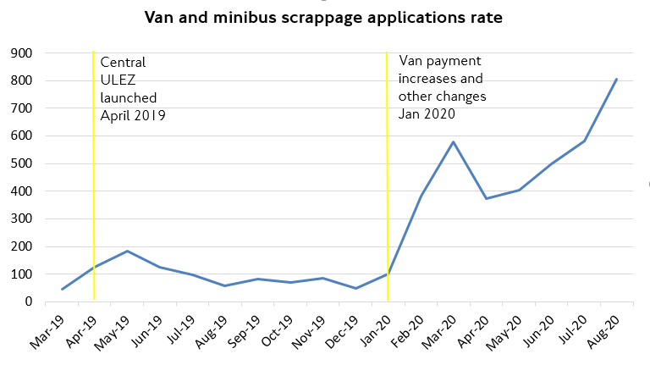

The scheme was suspended for van applications on 28 August 2020 due to high demand and a limited budget. It remained open for eligible charities to scrap minibuses until 24 November 2021, when all scrappage schemes closed.

1.2 Heavy vehicle scrappage scheme
The heavy vehicle scrappage scheme was launched on 28 September 2020.
There were two offers available for this scheme:
- Option A: £15,000 per vehicle scrapped and replaced with a ULEZ-compliant vehicle
- Option B: £15,000 per vehicle retrofit grant
Applicants could scrap or retrofit up to three non-compliant buses, coaches or heavy goods vehicles (HGVs). Applicants had six months to provide proof of scrappage and receive their payment. Due to high demand and limited funds, the scheme was suspended on 14 October 2020.
To be eligible for the scrappage option, the vehicle had to be an HGV, large van, specialist vehicle (more than 3.5 tonnes GVW), bus or coach (more than 5 tonnes GVW) and not compliant with the LEZ standards. The vehicle must have been owned by an eligible organisation for more than 12 calendar months before the start date of the heavy vehicle scrappage scheme, be insured for business use and be road-taxed with a valid MOT. It must have also been surrendered for secure scrapping at either the Perivale or Charlton Metropolitan Police Pound.
To be eligible for the retrofit option, the vehicle had to be a non-compliant HGV, large van, specialist vehicle, bus or coach. It needed to be owned by an eligible organisation for more than 12 calendar months before the start date of the heavy vehicle scrappage scheme. It must have also been insured for business use. Further, the vehicle needed to be on the Clean Vehicle Retrofit Accreditation Scheme (CVRAS) register, which sets out which vehicles are suitable to be retrofitted, and be retrofitted by a CVRAS-approved company.

1.3 ULEZ car and motorcycle scrappage scheme (UCMSS)
The UCMSS was launched on 23 October 2019 and the two scrappage options were:
- Option A: £2,000 scrappage grant for a car
- Option B: £1,000 scrappage grant for a motorcycle or moped
UCMSS applicants were not mandated to purchase a replacement vehicle. This was to allow applicants the flexibility of choice of how to spend the grant payment and to encourage uptake of other transport options.
To be eligible, applicants had to live within the 32 London boroughs or the City of London and receive at least one of a number of means-tested income benefits or non-means-tested disability benefits. The vehicle had to be registered by the applicant with the DVLA (or to someone at the same address as the applicant), be owned for more than 12 months before 23 October 2019, be insured, have an up-to-date MOT certificate and road tax, and not meet the ULEZ standards.
Once their vehicle was accepted as eligible, an applicant had 30 calendar days to provide proof of scrappage before receiving their payment.
A breakdown of the eligible benefits and example scenarios for those choosing these options can found in Appendix 1.

1.4 Other scrappage financial support schemes in the UK
The Mayor of London’s scrappage schemes were successful in helping Londoners on lower incomes, disabled Londoners, small businesses and charities prepare for the expansion of the ULEZ. The £61 million scheme has been the biggest of its kind in the UK to date, despite the UK government not offering financial support as they have to many other cities that have also been developing similar schemes, often to support Clean Air Zones (CAZs), as well as Future Mobility Zones, which have been recently launched in the UK.
This section gives details of other financial support schemes launched as part of other cities’ CAZs. A high-level breakdown of other scrappage/financial support schemes in the UK can be viewed in Table 1, with further detail given in Appendix 3.
Table 1: Other scrappage financial support schemes in the UK
City | Overall funding | Eligibility | Offer content
London | £61 million | Low income, disabled Londoners, small businesses and charities | Vans and minibuses: £7,000–£9,500  Heavy vehicles: £15,000  Cars: £2,000  Motorcycles: £1,000
Bath | £9.4 million CAZ funding | Charities, sole traders and small businesses | Taxis and PHVs: up to £4,500  Vans: up to £4,500  HGVs: up to £20,000  Buses and coaches: up to £35,000
Birmingham | £38 million CAZ funding | Earn less than £30k and work 18 hours max within the CAZ  SMEs for heavy vehicles  Taxis and PHVs | Cars: £2,000 mobility credit or towards a replacement vehicle  Heavy vehicles: £15,000  Taxis: £5,000  PHVs: £1,000–£2,500
Bradford | £30 million CAZ funding | Licensed taxis, SMEs, charities | Taxis: £3,200–£10,000  Vans and minibuses: £4,500  HGVs: Up to £16,000
Bristol | £42 million CAZ funding | Earn less than £27k and work within the CAZ  SMEs operating within the CAZ | Cars: £1,500 grant + £500 interest-free loan  Light Goods Vehicles: £4,500 grant + £1,500 interest  HGVs and coaches: up to £16,000
Coventry | £1 million from Future Mobility Zone grant | Applicants must live within a select list of Coventry wards (areas of air quality concern) | £3,000 of mobility credits
Portsmouth | £6.6 million CAZ funding | Wheelchair-accessible vehicles  Taxis/PHVs  Evidence of regular entry into the CAZ for HGVs and buses/coaches | Wheelchair-accessible vehicles: £5,000  Taxis and PHVs: £1,500  HGVs: £16,000  Buses/coaches: £15,000

2. Scrappage scheme operations

2.1 Scrappage application process
Applicants for the scrappage schemes could apply via the TfL website, by phone or by completing a postal application form. If their application was approved, they received a confirmation of eligibility letter from TfL. A high-level breakdown of the eligibility and application process for each scheme is shown in Table 2.
Table 2: High-level breakdown of scrappage scheme eligibility
Scrappage scheme | Eligibility criteria
Heavy vehicles scrappage scheme  Scheme was open from 28 September 2020 to 14 October 2020 to micro-businesses, small businesses, sole traders and charities | - Organisations had to be registered within Greater London, have an operator’s licence with an operating centre within Greater London, hold a London Service Permit or prove that their vehicle had made 26 journeys into Greater London during the six months before the start of the heavy vehicle scrappage scheme  - Successful applicants had six months  to provide proof of scrappage or retrofit
Van and minibus scrappage scheme  Scheme was open to micro-businesses,  sole traders and charities (from 22 February 2019) and small businesses (from January 2020). Applications for the van scheme were suspended on 28 August 2020 due to high demand and a limited budget. It remained open for eligible charities to scrap minibuses until 24 November 2021, when all scrappage schemes closed | - Organisations had to be registered  within Greater London or the UK with  a minimum number of journeys into the Congestion Charge zone (for some options)  - Maximum of three vehicles could be scrapped  - Successful applicants had six months  to provide proof of scrappage
Car and motorcycle scrappage scheme  The scheme was open from 23 October 2019 to 24 November 2021 to applicants living within the 32 London boroughs or the City of London and receiving certain means-tested income benefits or non-means-tested disability benefits | - Vehicle had to be registered by the applicant, owned for more than 12 months before 23 October 2019,  be insured, have an up-to-date MOT certificate and road tax, plus not meet the ULEZ emissions standards  - Successful applicants had 30 days  to provide proof of scrappage

2.2 Impact of scrappage schemes
This section sets out the number of successful applications for each scheme (broken down into those accepted or rejected), the number of vehicles scrapped, and the uptake of third-party offers for UCMSS.
Table 3 shows the final total scrappage figures across all schemes. It shows the success of these schemes in removing more than 15,200 older and more polluting vehicles from London’s roads.
Table 3: Final scrappage figures across all scrappage schemes
Vehicle type | Vehicles scrapped | Scrap only | Scrap and replace with Euro 6 | Scrap and replace with EV | Retrofit | Total
UCMSS: cars | 9,786 | - | - | - | - | 9,786
UCMSS: motorcycles | 52 | - | - | - | - | 52
Vans and minibuses | - | 566 | 4,524 | 169 | - | 5,259
Heavy vehicles | - | - | 123 | - | 12 | 135
TOTAL | 9,838 | 566 | 4,647 | 169 | 12 | 15,232

2.2.1 Van and minibus scrappage scheme
There were a total of 19,081 applications for the van and minibus scrappage scheme. Figure 2 shows that, of these applications, 29 per cent were accepted and therefore moved on to stage 2 of the process where an applicant could proceed to scrap their vehicle.
Due to eligibility criteria not being met, 18 per cent of applications were rejected. Another 40 per cent were sent back to the applicant requiring further evidence. A further 11 per cent of applications were duplicate requests (multiple applications from the same person), three per cent were invalid (e.g. a general enquiry submitted as an application) and less than one per cent were withdrawn.
Figure 2: Van and minibus scrappage applications at stage 1 of the process
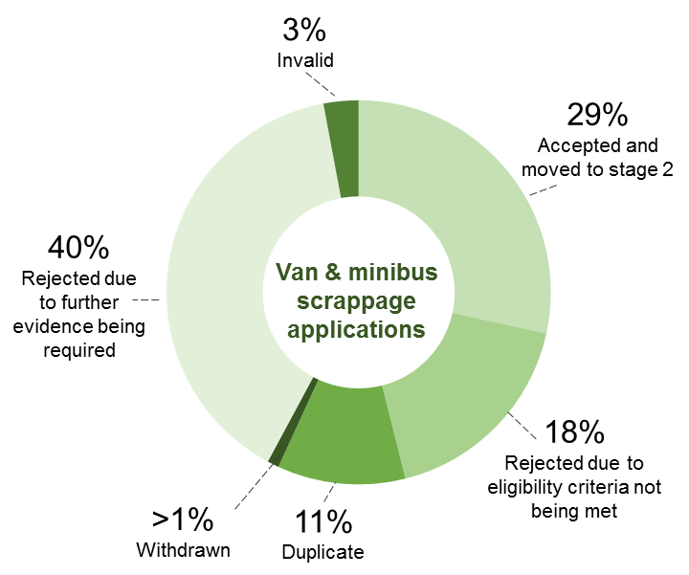

Of the 5,440 applications accepted, 84 per cent (5,259) submitted evidence of scrappage and/or a replacement vehicle for validation, and then received their scrappage grant. There were no rejected payment requests recorded, but some accepted applications expired without progression to stage 2 and scrappage of a vehicle.
Figure 3 shows the breakdown of vehicles scrapped for each option for the van and minibus scrappage scheme.

Figure 3: Van and minibus scrappage scheme breakdown
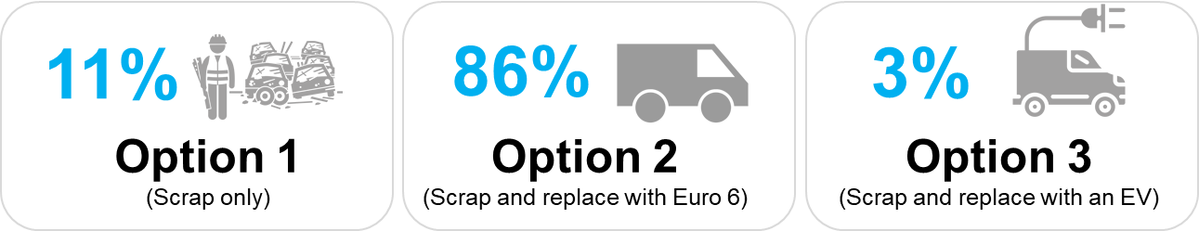

2.2.2 Heavy vehicle scrappage scheme
The heavy vehicle scrappage scheme attracted a total of 470 applications. Figure 4 shows that, of these, 33 per cent were accepted, 55 per cent rejected, 11 per cent were duplicate applications and less than one per cent were withdrawn. Reasons for rejection included not meeting the scheme rules or submitting incomplete application forms.
Figure 4: Heavy vehicle scrappage applications processed breakdown
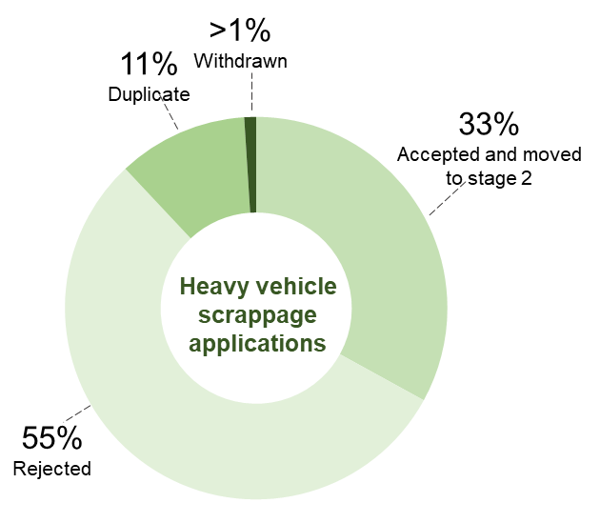
Figure 5 shows the breakdown of heavy vehicles scrapped and replaced with ULEZ-compliant vehicles. Of the vehicles that were scrapped and replaced, 90 per cent were HGVs compared to only 10 per cent of buses/coaches.
Figure 5: Breakdown of heavy vehicles scrapped and replaced
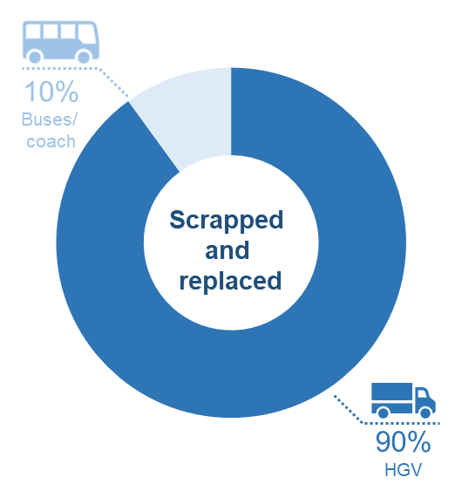
Figure 6 shows the breakdown of heavy vehicles retrofitted to be ULEZ-compliant. The retrofit option was mostly used by bus or coach owners.
Figure 6: Breakdown of heavy vehicles retrofitted
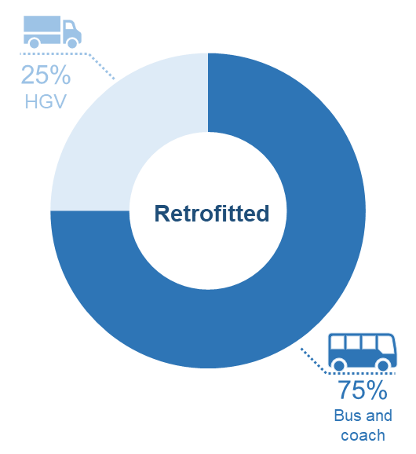

2.2.3 Car and motorcycle scrappage scheme
There was a high level of interest in the UCMSS, with a total of 23,715 applications made. However, some applications were rejected or withdrawn/invalid (58 per cent), with 42 per cent accepted at stage 1. As set out in section 1.3, there were criteria established to confirm eligibility and reduce any risk of fraud, which may have been a reason for the high rejection or withdrawn/invalid rate.
Figure 7 indicates that the reasons for rejection at stage 1 included insufficient evidence submitted (25 per cent), V5C logbook incomplete (eight per cent) and V5C logbook ownership (seven per cent).
Figure 7: Car and motorcycle applications processed breakdown
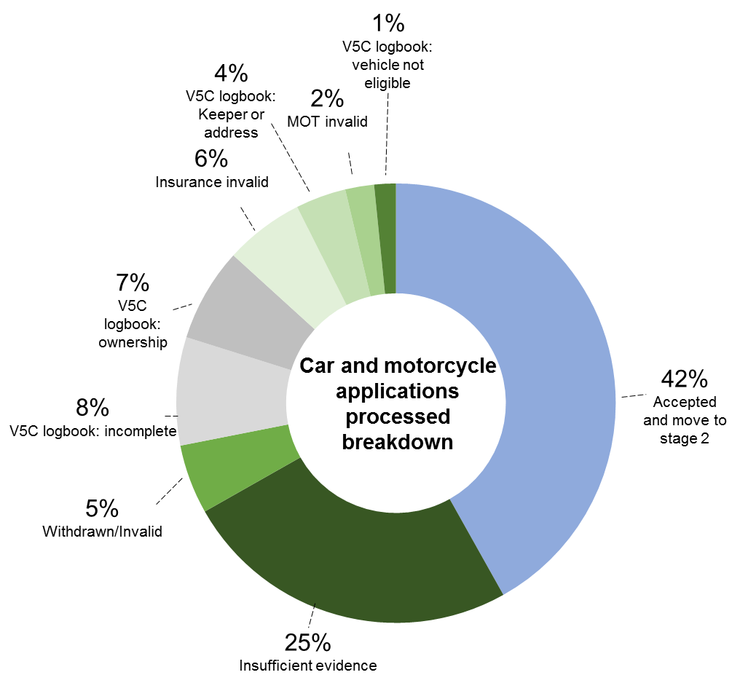
Figure 8 shows that 59 per cent of recipients of the UCMSS grant payment live in postcodes within the ULEZ boundary, while 41 per cent live in postcodes outside the ULEZ boundary, in outer London.
Figure 8: Recipients of UCMSS grant payment by area in London
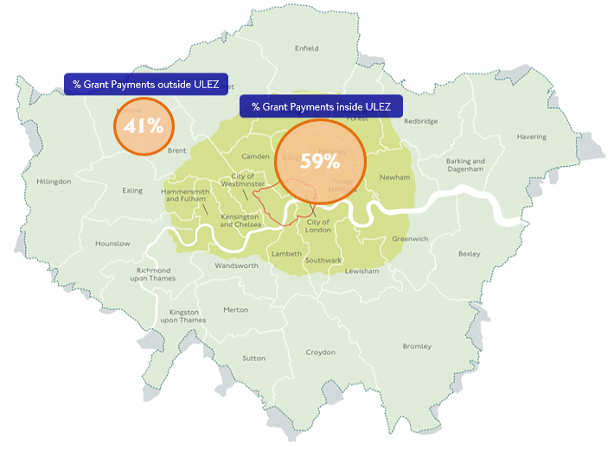

The UCMSS specifically targeted low income and disabled Londoners with non-compliant cars and motorcycles who would find it hardest to adapt to the ULEZ. Figures 9 and 10 indicate that higher numbers of scrappage grant payments were made to residents of London boroughs with high areas of multiple deprivation. A full borough breakdown of UCMSS grant payments can be found in Appendix 2.
Figure 9: Index of multiple deprivation 2019, LSOAs in London
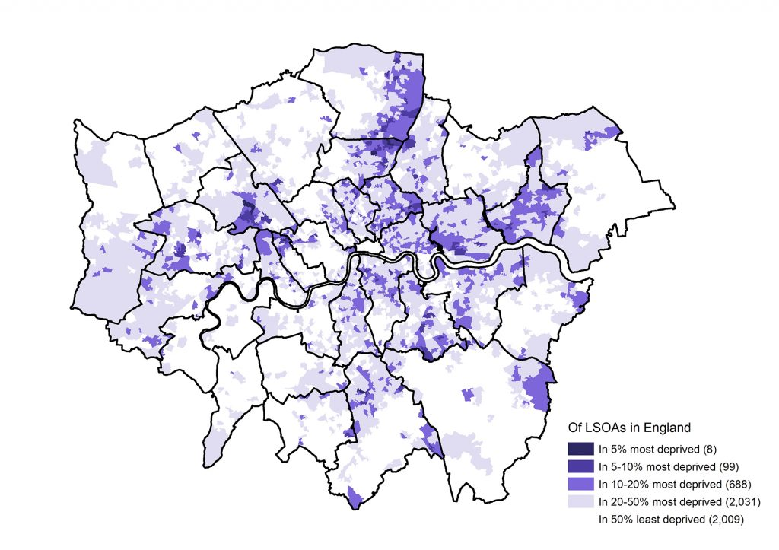
Figure 10: Borough breakdown of recipients of the UCMSS grant, including areas of high and low deprivation
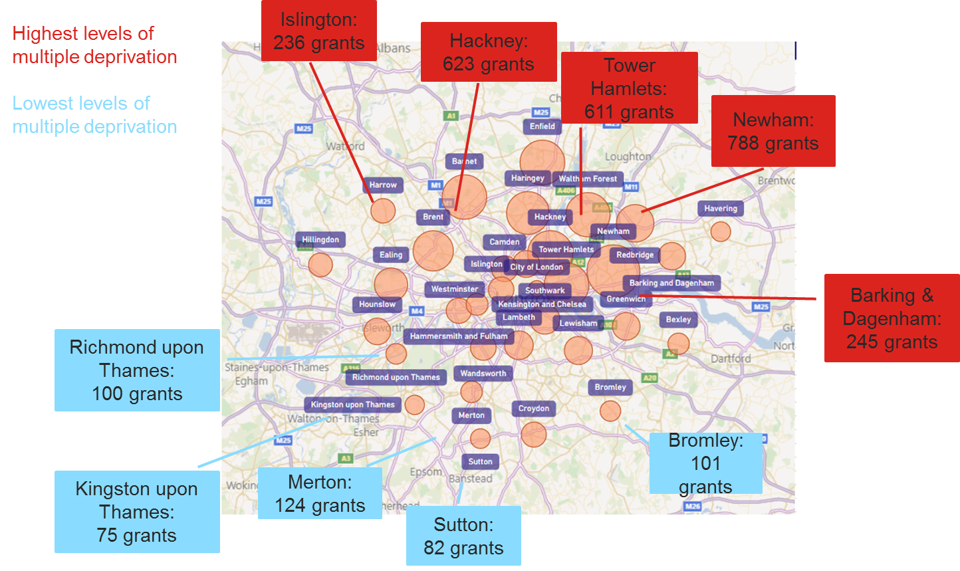

2.2.4 Scrappage emission benefits
Looking at only the number of vehicles scrapped, it is estimated that the scrappage schemes have supported the removal of up to 170 tonnes of NOx, 0.7 tonnes of PM2.5 and 28,400 tonnes of CO₂. This shows that scrappage schemes can be used as an effective policy intervention to remove NOx, PM2.5 and CO₂ from London’s roads. These calculations are based on average annual mileage information for vehicles and are simply calculating the potential impact on emissions of their removal, not making assumptions about how replacement journeys are made.
However, the data shows that many of the vehicles scrapped were replaced with another vehicle, meaning the above calculations represent a best case of what could be achieved with a scheme of this size if no vehicles were replaced.
Information from respondents to the car and motorcycle scrappage scheme survey indicate that 66 per cent replaced their vehicle with a car or motorcycle, with 34 per cent not using the grant payment on a replacement car or motorcycle (see section 3.3). Within the 66 per cent who replaced their vehicle with a car or motorcycle, 75 per cent bought a petrol car, 21 per cent bought a diesel car, three per cent bought an EV and one per cent bought a motorcycle.
Taking this into account and based on the same mileage assumptions, we estimate that overall emissions savings across all scrappage schemes would be around 140 tonnes of NOx, 0.5 tonnes of PM2.5 and 2,000 tonnes of CO₂.
Table 4 shows the estimated emissions savings from the three scrappage schemes under each scenario described above.

Table 4: estimated emissions savings from the three scrappage schemes with and without vehicle replacement
Scrappage scheme | Emissions savings if  no replacement vehicle (tonnes) |  |  | Emissions savings with replacement vehicle (tonnes)
- | NOx | PM2.5 | CO₂ | NOx | PM2.5 | CO₂
UCMSS | 60 | 0.2 | 13,200 | 50 | 0.2 | 500
Van & minibus | 50 | 0.1 | 9,500 | 30 | 0.0 | 1,200
Heavy vehicles | 60 | 0.4 | 5,700 | 60 | 0.4 | 300
All schemes | 170 | 0.7 | 28,400 | 140 | 0.5 | 2,000

2.2.5 Third-party offers
To support a shift to more sustainable transport (including to ULEZ-compliant vehicles) for successful applicants to the scrappage schemes, we worked with transport industry partners to identify third-party offers. Table 5 shows the offers that were available.

Table 5: Third-party offers available to successful UCMSS and van and minibus scrappage scheme applicants
Offer | UCMSS | Van and Minibus
Mitsubishi Motors: lease purchase option on Outlander PHEV Commercial | ☓ | ✔
The Car Loan Centre: car finance discounts, free MOT or servicing | ✔ | ☓
Zero Emissions Network: free car club membership and discounts in Hackney, Islington and Tower Hamlets | ☓ | ✔
Santander Cycles: one-year free membership | ✔ | ☓
Zipcar: subsidised membership | ✔ | ✔

Overall, the third-party offers did not attract high levels of take-up. Feedback indicated that they were not varied enough, were not well publicised and could have been easier to find on the TfL website. For any future scrappage scheme, third-party offers should be a more prominent element of the overall scrappage package, with more offers across a wide range of options, to encourage a shift to sustainable modes of transport or zero emission vehicles.
Lessons learned from this scheme also indicate that third-party offers should be better signposted during the application process and better promoted via TfL communication and marketing channels. Partnerships should be created with third parties to ensure that they are also promoting the scheme and their offer to maximise its benefits.

3. Car and motorcycle scrappage scheme survey
Between 4 and 23 March 2022, following the closure of the UCMSS, we issued an online questionnaire via research agency 2CV to evaluate the scrappage scheme.
Questions covered the following topics:
- Perceptions of the scheme
- Third-party offers
- How grant money was used
- Behaviour change
- Reflections that could inform potential future scrappage schemes
2CV issued the questionnaire to 5,600 recipients of the grant for whom we held email addresses. To maximise responses, a competition offered the chance to win one of three £50 high street shopping vouchers. We received 324 responses, a response rate of six per cent (higher than the expected two per cent response rate).

3.1 Perceptions of the scheme
The scrappage scheme was perceived as playing a successful role in tackling air pollution on London’s roads (49 per cent agreed). Many grant recipients felt it has also had a direct impact on them personally: making them feel part of the solution to poor air quality in London (52 per cent agreed) and helping them to travel in more environmentally friendly ways (49 per cent agreed).
Most grant recipients first heard about the scheme through word of mouth (44 per cent), usually from a family member or friend (26 per cent), although many also heard about it through TfL (18 per cent). This indicates that more could be done via TfL communication channels to improve awareness of any future scrappage scheme.
Overall, 82 per cent of applicants felt that the application process was ‘very easy’, ‘easy’ or gave a neutral response. However, those on disability benefits found it more difficult: 31 per cent of disability benefits’ recipients vs 13 per cent of Income Support recipients said the process was ‘not easy’ or ‘not at all easy’ and were less satisfied as a result. Table 6 shows the full results of the ease of the application process.
Table 6: Perceptions of the ease of the application process
Perception | All recipients | Income Support | Disability benefits
Very easy | 38% | 41% | 30%
Easy | 25% | 26% | 23%
Neutral | 19% | 19% | 16%
Not easy | 8% | 6% | 11%
Not at all easy | 10% | 7% | 20%
Overall, 26 per cent scored the application process 10/10 in terms of satisfaction (41 per cent scored this between 7/10 and 10/10), showing good levels, but also that there is room for improvement.
To improve perceptions of any potential future scrappage scheme, the application process should be made as simple as possible, by improving the user interface and ensuring applicants have a clear understanding of where they are in the application process.

3.2 Third-party offers
Third-party offers played a small role in motivating recipients to apply for the scrappage scheme, with limited awareness the key barrier to use: 47 per cent were not aware of third-party offers. Satisfaction with third-party offers was relatively low compared with other aspects of the scheme: around 4 in 10 recipients aware of available offers told us they were neither satisfied nor dissatisfied.
A small number of recipients (13 per cent) had used at least one of the third-party offers. The Santander Cycles promotion of free annual membership reached the highest number of recipients in terms of both awareness and take-up. Despite low take-up, many respondents (65 per cent) reported they would be interested in third-party offers in any future such scheme.

3.3 How the grant money was used
The grant money was a key element in satisfaction with the scheme: 39 per cent scored it 10/10 (the most satisfactory element of the scheme). Most recipients felt that the grant money was either a ‘very reasonable’, or a ‘reasonable’ amount (57 per cent). A further 20 per cent of recipients thought it was an ‘unreasonable’ amount.
Figure 11 shows that two-thirds of recipients used the grant payment to buy a replacement ULEZ-compliant car or motorcycle. Within this group, 75 per cent bought a petrol car, 21 per cent bought a diesel car, three per cent bought an EV and one per cent bought a motorcycle. Of the 34 per cent who did not purchase a ULEZ-compliant vehicle, 20 per cent spent the grant on their household finances, 17 per cent paid off debt, 17 per cent saved it, eight per cent covered public transport costs and three per cent bought a bicycle or e-bike.
Figure 11: Use of scrappage grant payments
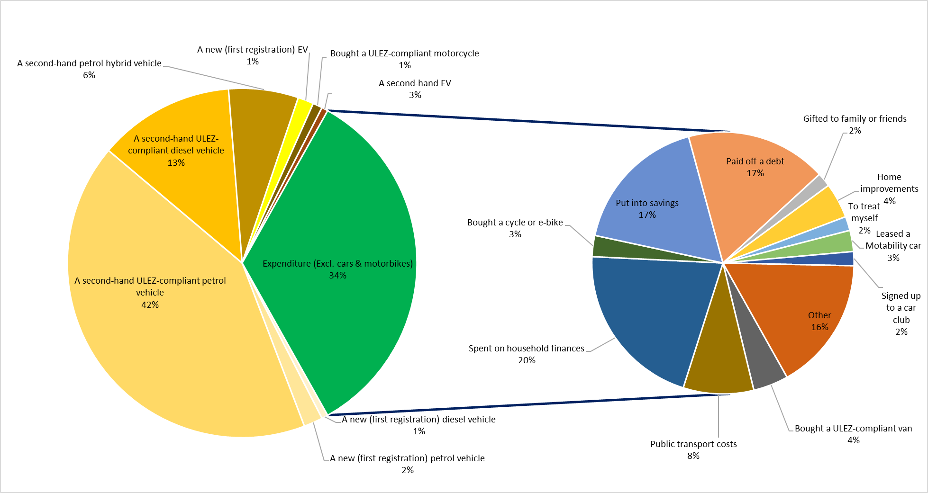

3.4 Behaviour change
The results show that the scrappage schemes were effective in supporting drivers of non-compliant vehicles to shift to more sustainable modes of transport.
Two-thirds of recipients bought a ULEZ-compliant vehicle, with one-third using their grant payment on something else. Amongst all recipients, 22 per cent report no longer having access to a vehicle in their household. Figure 12 shows that there is evidence of changed travel behaviour, with 17 per cent of respondents reporting increased public transport use and 10 per cent reporting increased active travel. Further, nine per cent now travel less by car.
Figure 12: Percentage change in mode use by recipients of the UCMSS grant payments

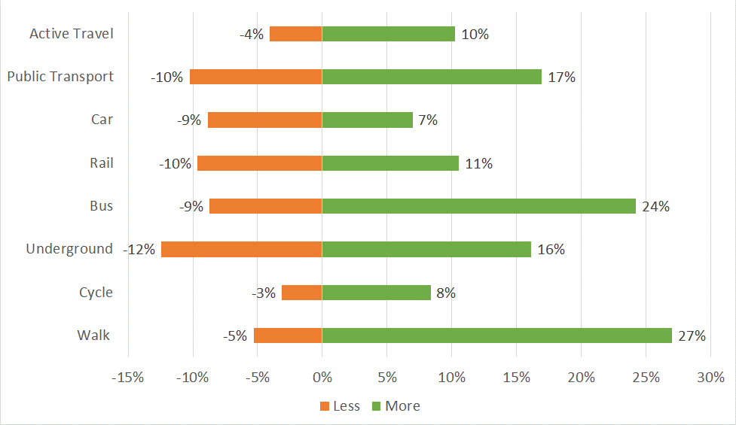

Looking at the net increase or decrease in recipients’ travel in Figure 13, the biggest change in mode was walking (22 per cent net increase), followed by bus (17 per cent net increase), cycle (five per cent net increase) and rail (one per cent net increase). There was a net decrease of two per cent in car travel.

Figure 13: Net change in mode use by recipients of the UCMSS grant payments
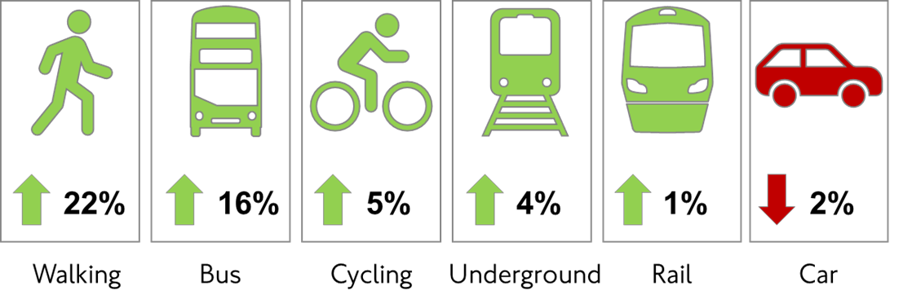

3.5 Implications for potential future scrappage schemes
Thinking about any potential future scrappage schemes, Figure 14 shows the most suggested alternative payment option was a higher grant towards purchase of an EV (69 per cent). Other suggestions included an annual public transport season ticket (24 per cent), taxi credit (22 per cent) or vouchers for a new bicycle or e-bike (19 per cent).
However, for any potential future scrappage scheme, the feasibility of implementation and overall alignment with the scheme’s objectives would need to be considered. For example, with limited funding, higher payment levels would mean fewer total payments available, reducing the number of people a scheme could support.
Figure 14: Interest in alternative grant payment options
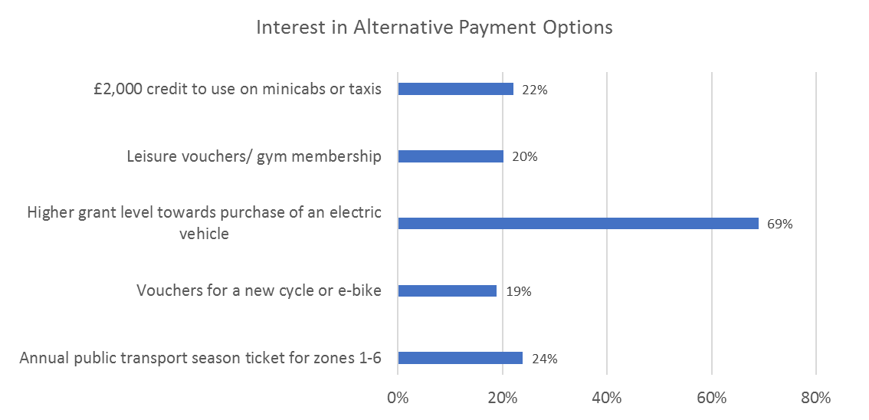

3.6 Key survey findings
The UCMSS survey has shown that scrappage schemes can be an effective tool to help reduce car ownership and support mode shift to active travel and public transport.

Following the scheme, 22 per cent of respondents stated that they no longer have access to a vehicle in their household. Respondents have reported travelling actively more frequently, including a 22 per cent net increase in walking. There has also been a net increase in travel by public transport of seven per cent, including a 16 per cent net increase in bus travel.

Another key finding was the importance of improving the customer experience of the application process, particularly for disabled applicants: making this as simple as possible is key to enhancing perceptions of the scheme.

The grant payment levels of £1,000 for motorcycles and £2,000 for cars were considered appropriate, with 57 per cent finding these ‘very reasonable’ or ‘reasonable’ amounts. There was interest in alternative payments to the grant, which included options that would support mode shift away from the car.

The UCMSS survey gave an insight into how respondents replaced their vehicles, which has allowed us to estimate emissions savings made by the scheme. It has shown that UCMSS has saved around 50 tonnes of NOx, 0.2 tonnes of PM2.5 and 500 tonnes of CO2.

Finally, respondents reported high interest in third-party offers for any potential future scheme (65 per cent). However, the survey indicated that the supporting third-party offers had low awareness rates (47 per cent). It is therefore important to ensure good awareness of such offers; for example, via TfL and partner communication channels. A wide range of attractive third-party offers would also help to maximise the benefits of a scheme in reducing emissions and supporting mode shift.

4. Recommendations for potential future schemes
The scrappage schemes were clearly a successful mitigation measure to support Londoners on lower incomes, disabled Londoners, small businesses and charities who would have found it more difficult to afford to adapt to the ULEZ expansion and tightening of the LEZ standards. The £61 million fund set up by the Mayor helped remove 15,232 older and more polluting vehicles from London’s roads. Our survey showed that 22 per cent of UCMSS grant recipients no longer have access to a vehicle in their household.
Key to any potential future scrappage scheme would be to build on the successes of earlier schemes, but also to make improvements where necessary. For example, the car and motorcycle survey showed that disabled people found the scrappage application process more difficult than those who claim other benefits. It is therefore important to improve the application process, making it as straightforward as possible and easier for the applicant to understand where they are in the application process.
Further, a targeted multichannel marketing campaign would help ensure that those who are eligible for the scheme are aware of it. Nearly half of applicants (44 per cent) found out about the UCMSS through word of mouth.
Alternatives to the grant payment should also be considered, to further support the shift to sustainable modes of transport. This shift should be encouraged by working with third-party industry partners to identify a diverse range of offers, widely marketed to ensure that awareness and take-up are maximised.

Appendices

Appendix 1: Eligible benefits for UCMSS grant payments with example scenarios
Table 7: Eligible benefits for UCMSS grant payments with example scenarios
Means-tested benefit | Purpose and eligibility
Pension Credit | Gives extra money to help with living costs if over State Pension age and on a low income. To be eligible, someone must:  - live in Great Britain  - if they have a partner, either:  - both they and their partner have reached State Pension age  - one of them is getting Housing Benefit for people over State Pension age  Pension Credit tops up:  - weekly income to £182.60 if single  - joint weekly income to £278.70 if have a partner
Universal Credit | To help with living costs. Someone may be eligible if on a low income,  out of work or unable to work. To be eligible someone must:  - live in UK  - be 18 or over  - or if 16 or 17 years, meet certain criteria  - have £16k or less in money, savings or investments  Using an online calculator tool, the following are example scenarios in which someone may or may not be eligible. These suggest that those on average London salaries for an emergency NHS worker or care worker would likely be eligible if they lived alone and therefore relied on a single income (Hospital porter: £19k, Nurse: £38k, Nurse’s associate: £25k, Care worker: £23k, Paramedic: £36k).  Someone earning up to £39k, living alone in a one-bed flat (costing £1,100 p/m), council tax band B, and no savings, would likely be eligible.  Someone earning up to £59k, living with one child in a two-bed flat (costing £1,400 p/m), council tax band B, and £10,000 savings, would likely be eligible.  A couple, both earning £19k each (combined gross salary £38k), renting  a two-bed flat, paying £1,400 p/m), council tax band B, and £5k savings, would likely be eligible.  Owning a home makes it harder to qualify e.g. a single person who owns their own home, has £200,000 outstanding on the mortgage and pays £1,000 a month, and whose salary is £18k and no savings, would likely not be eligible.
Child Tax Credit | Universal Credit has replaced tax credits for most people. Someone can only make a claim for Child Tax Credit if they already get Working Tax Credit. Someone can usually get Child Tax Credit for each child or young person they are responsible for until 31 August after they turn 16.
Housing Benefit | Being replaced by Universal Credit. To help pay rent if unemployed, on a low income or claiming benefits. To make a new claim for Housing Benefit, one of the following must apply:  - reached State Pension age  - live in supported, sheltered or temporary housing  Usually someone would be ineligible if they:  - have savings greater than £16,000  - are paying a mortgage on their own home  - live in the home of a close relative  - are a full-time student  - have reached State Pension age but their live-in partner has not
Income Support | No longer available to new applicants, replaced by Universal Credit.  To have been eligible, the following must have applied (summarised):  - savings no greater than £16,000, and either no or low income  - not in full-time paid work  - aged between 16 and Pension Credit qualifying age  - live in Great Britain  - a further qualifying factor from an extensive list e.g. pregnant,  lone parent or carer
Income-based Jobseeker’s Allowance | No longer available to new applicants, replaced by Jobseeker’s Allowance (JSA), which is no longer income-based. To be eligible for the new JSA, someone must have both:  - worked as an employee  - be 18 or over, but under State Pension age  - not be in full-time education  - be available for and actively looking for work  - not be working currently, or working fewer than 16 hours per week on average  - not have an illness or disability that stops them from working  - live in Great Britain  - paid Class 1 National Insurance contributions, usually in the last two to three years  They will not usually be eligible if they were self-employed and only paid Class 2 National Insurance contributions.
Income-related Employment and Support Allowance | No longer available to new applicants, replaced with Employment and Support Allowance, which is no longer income-based. This benefit is to give support with living costs if someone is unable to work due to a disability or health condition, or to support them getting back into work if they are able to. For someone to be eligible they must have:  - worked as an employee or have been self-employed  - paid enough National Insurance contributions
Working Tax Credit | Someone can only make a claim for Working Tax Credit if they already get Child Tax Credit. To be eligible, they must work a certain number of hours a week, based on their age and circumstances (e.g. disabled or have children). There is no set limit for income eligibility because it depends on circumstances.  For example, £18,000 for a couple without children or £13,100 for a single person without children. But it can be higher if they have children, pay for approved childcare or they or their partner are disabled.
Non-means-tested benefits | Purpose and eligibility
Personal Independence Payment (PIP) | PIP can help with extra living costs if someone has both:  - a long-term physical or mental health condition or disability  - difficulty doing certain everyday tasks or getting around  because of their condition  Someone can get PIP if all the following apply:  - are 16 or over  - have a long-term physical or mental health condition or disability  - have difficulty doing certain everyday tasks or getting around  - expect the difficulties to last for at least 12 months from  when they started  - are under State Pension age if not received PIP before
Disability Living Allowance | Being replaced by other benefits, including Personal Independence Payment and Adult Disability Payment.  The benefit was to help with care and mobility needs if someone is living with a disability.
Attendance Allowance | Helps with extra costs if someone has a disability severe enough that they need someone to help look after them. Someone can get Attendance Allowance if they have reached State Pension age and the following apply:  - have a physical disability, a mental disability, or both  - disability is severe enough for them to need help caring for themselves or need someone to supervise them, for their own  or someone else’s safety  - have needed that help for at least six months (unless they might have six months or less to live)
Armed Forces Independence Payment | An additional allowance that provides financial support for service personnel and veterans who have an Armed Forces Compensation Scheme (AFCS) Guaranteed Income Payment (GIP) within Bands A – C.
War Pensioners’ Mobility Supplement  (WPMS) | WPMS is paid with the War Disablement Pension to help with extra mobility costs due to disability caused during service. To be eligible:  - a War Pension must be in payment for the amputation of one  or both legs, or  - War Pension must be 40 per cent or higher, and  - the conditions that the War Pension is for are the main reason  they are unable to walk, or why they find walking difficult, or  - the conditions that the War Pension is for are the main reason  why trying to walk could put them in danger or seriously damage their health, or  - they cannot walk outside without someone’s help and their War Pension is for loss of vision assessed at 90 per cent or more and hearing loss at 80 per cent or more
Carer’s Allowance | Someone can be eligible if they care for someone for at least 35 hours a week and they get certain benefits. They may be eligible for Carer’s Allowance if they, the person they care for and the type of care they provide meet certain criteria.  See www.gov.uk/carers-allowance/eligibility for the extensive list.
Severe Disablement Allowance | Now replaced with Employment and Support Allowance (ESA). This benefit was for people with severe disabilities, aged between 16 and 65, who have been unable to work due to illness or disability for more than 28 weeks and who have not paid the required National Insurance contributions to qualify for other benefits.
Employment and Support Allowance (ESA) | For people with a disability or health condition that affects how much they can work. ESA gives:  - money to help with living costs if they are unable to work  - support to get back into work if they are able  Someone can apply if they are under State Pension age and have a disability or health condition that affects how much they can work. They also need to have both:  - worked as an employee or have been self-employed  - paid enough National Insurance contributions, usually in the last two to three years
Industrial Injuries Disablement Benefits (IIDB) | Someone might get IIDB if they became ill or are disabled because of an accident or disease, either:  - at work  - on an approved employment training scheme or course  They must be employed, and not self-employed.
Constant Attendance Allowance | Someone can claim the Constant Attendance Allowance if they get IIDB or a War Disablement Pension and need daily care and attention because of a disability. They must be claiming one of the following:  - Industrial Injuries Disablement Benefit  - War Disablement Pension

Appendix 2: Car and motorcycle scrappage uptake by borough
Figure 15: Car and motorcycle scrappage uptake by borough
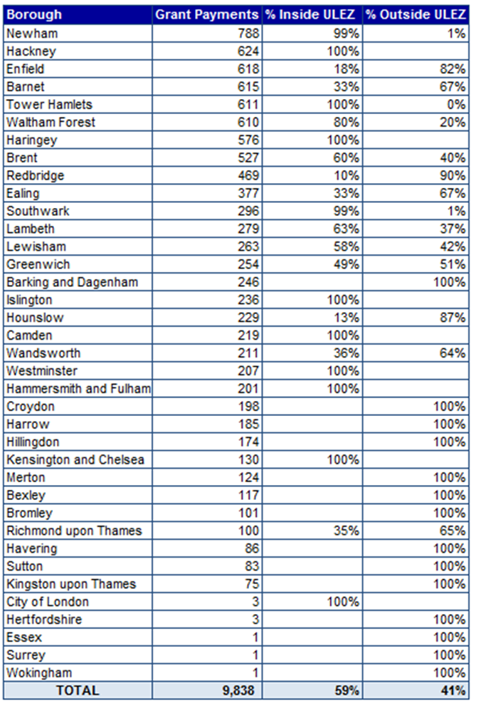

Appendix 3: Other scrappage financial support schemes comparisons
The Mayor of London’s scrappage schemes were successful in supporting low income and disabled Londoners, small businesses and charities to prepare for the expansion of the ULEZ. The £61 million scrappage schemes have been the largest of their kind in the UK to date, compared to other Clean Air Zones (CAZs) launched in the UK. This section gives details of other scrappage schemes launched as part of other cities’ CAZs, with details of other scrappage CAZs due to be launched.

UK comparisons
Within the UK, outside of London, CAZs are being widely introduced. These are schemes supported by the UK government with targeted action to improve air quality, with resources prioritised and coordinated to deliver improved health benefits. Local authorities can apply charges to non-compliant vehicles, using powers under the Transport Act to deliver nitrogen dioxide reductions.
Table 8 shows the four classes of CAZs (outside London) ranging from Class A to Class D, affecting different vehicle types. Table 9 shows the status of UK CAZs.
Table 8: Class of CAZs in the UK outside London
Class | Vehicle types affected
A | Buses, coaches, taxis, private hire vehicles
B | Buses, coaches, taxis, private hire vehicles, heavy goods vehicles
C | Buses, coaches, taxis, private hire vehicles, heavy goods vehicles, vans, minibuses
D | Buses, coaches, taxis, private hire vehicles, heavy goods vehicles, vans, minibuses, cars. The local authority has the option to include motorcycles

Table 9: Status of UK CAZs
Location | Launch | Class of CAZ
Bath | Active: 15 March 2021 | C
Birmingham | Active: 1 June 2021 | D
Portsmouth | Active: 29 November 2021 | B
Bradford | Active: 26 September 2022 | C+
Bristol | Due: 28 November 2022 | D
Tyneside | Due: 30 January 2023 | C
Sheffield | Due: spring 2023 | C
Greater Manchester | Under review | Under review

Bath
The UK government awarded Bath £9.4 million for their CAZ, with £7.2 million allocated to support vehicle scrappage. The zone was introduced in March 2021 and is targeted at LGVs, HGVs, coaches, buses, taxis and PHVs.
Birmingham
Birmingham City Council received £38 million from the UK government in May 2021 to support their CAZ, with some funding allocated to a vehicle scrappage scheme. This is aimed at buses, coaches, taxis, PHVs, heavy goods vehicles, vans, minibuses and cars.
Portsmouth
Portsmouth introduced their CAZ in November 2021, affecting non-compliant wheelchair-accessible vehicles, taxis, PHVs, buses, coaches and HGVs. The city has been awarded £6.6 million for their CAZ from the UK government with £3.2 million allocated to help drivers to upgrade or retrofit their vehicles.
Bradford
Bradford has three separate funding schemes to support the owners of licensed taxis, LGVs, and heavy vehicles to upgrade their vehicles to meet their CAZ standards. Together, the schemes have more than £30 million allocated to them from the UK government.
Bristol
Bristol received £42 million from the UK government to support their CAZ. Of this, £32 million has been given to businesses to upgrade their non-CAZ-compliant HGVs, LGVs, taxis and PHVs. £1.8 million was put aside for loans and grants to support individuals to upgrade their vehicles. A further £5.9 million has supported a shift towards sustainable transport, including funding for free e-bike loans, bicycle training and free bus tickets.
Tyneside
Newcastle initially planned to introduce a CAZ in July 2022, but this has been postponed until 30 January 2023. Charging will be introduced in two phases, with non-compliant taxis, PHVs, buses, coaches and HGVs being charged from 30 January 2023. Vans and LGVs will not face charges until July 2023. Newcastle City Council and Gateshead Council have confirmed there will be vehicle upgrade grants made available from funding from the UK government to support the replacement or upgrade of non-CAZ-compliant vehicles.
Sheffield
The Sheffield CAZ is due to come into effect in spring 2023. HGVs, LGVs, buses and coaches plus taxis and PHVs will be impacted by the scheme. With funding from the UK government, Sheffield plans to offer financial support to those impacted to upgrade to cleaner vehicles.
Greater Manchester
Greater Manchester had planned to introduce a CAZ in May 2022, which would charge non-CAZ-compliant buses, coaches, taxis, LGVs and HGVs. Private vehicles were intended to be exempt from the scheme.
However, the Mayor of Greater Manchester made a decision that Greater Manchester would not be able to achieve compliance with the legal limit for harmful nitrogen dioxide (NO₂) air pollution by 2024. The legal direction that required compliance with the legal limit by 2024 was deferred until 2026, following agreement with the UK government.
Greater Manchester has resubmitted plans to the UK government for a new clean air plan, which is currently under review. This plan recommends that previously proposed CAZ charges be scrapped, while retaining the £120 million previously agreed to help people upgrade to compliant vehicles.
Coventry
As part of the West Midlands Future Transport Zone, Coventry was awarded £1 million towards their mobility credit scheme from the UK government. Launched in March 2021, through this scheme, older, polluting vehicles (pre-2016 diesel or pre-2011 petrol) were scrapped, with successful scheme applicants awarded £3,000 in mobility credits. These credits could be used on public transport and other transport services such as car clubs, bikeshare, taxis and on-demand bus services. Credits were loaded onto a debit card and could also be used for train travel to cities outside of the West Midlands.

International comparisons
Barcelona
Residents in the metropolitan area of Barcelona who own a diesel car (up to Euro 3) or petrol car (up to Euro 2) can scrap their vehicles and benefit from a T-Verda public transport card, free to use for three years. This scheme was introduced in 2017 and is funded by the regional government.
California
Residents of select areas in Los Angeles, Riverside, San Bernardino and Orange counties in California can receive up to $9,500 to replace an older polluting vehicle with a new or used electric or hybrid vehicle. Or they can choose to receive up to $7,500 in incentives to access public, private, and shared mobility options.

Appendix 4: Scrappage financial support schemes sources
- Bath’s Clean Air Zone
- Birmingham Breathes
- Cleaner Air Portsmouth
- Breathe Better Bradford
- Bristol’s Clean Air Zone
- Tyneside Breathe Clean Air
- Sheffield’s Clean Air Zone
- Greater Manchester Clean Air Plan
- Barcelona Scrappage Scheme
- California Scrappage Scheme

Based on average annual mileage information for vehicles
The CVRAS register shows which vehicles are eligible to be retrofitted by a CVRAS-approved company. Due to technological limitations, not all vehicles can be retrofitted with CVRAS technology and therefore would not qualify for the retrofit scrappage option
Index of multiple deprivation is a combined measure of deprivation based on a total of 37 separate indicators grouped into seven domains, each of which reflects a different aspect of deprivation experienced by individuals living within an area
Reasons for locations outside of London include a change of address during the application process
Calculated based on the use of UCMSS grant money reported in the 2CV survey and the share of vans and minibuses scrapped only, scrapped and replaced with a compliant combustion vehicle, and scrapped and replaced with an EV plus the share of heavy vehicles either scrapped with a compliant combustion vehicle or retrofitted
Example scenarios are correct at time of publishing but may differ from when the scheme was live
Example scenarios are calculated using the online tool at https://www.betteroffcalculator.co.uk/
Source: Glassdoor
Reasons for locations outside London include a change of address during the application process

